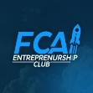
Project Documentation & Business Proposal
Project Name: FCAI E-Club
Prepared for: Eng. Mohamed Mohamed Hassan Fahmy
Prepared By: Eng. Ahmed Wael Mohamed
Date: August 17, 2026
Version: v1.1

PART 1: EXECUTIVE BUSINESS PROPOSAL
EXECUTIVE SUMMARY
FCAI E-Club is a non-profit student-led organization bridging the gap between academic theory and industry reality for engineers and entrepreneurs. Currently operating without a centralized digital footprint, the club requires an online platform to establish its brand identity, manage its growing membership, showcase its operational impact, and facilitate its extensive calendar of technical workshops and events.
This proposal outlines the development of a comprehensive web application that serves as the central nervous system for the E-Club. By investing in this platform, FCAI E-Club will professionalize its operations, attract high-value industry partners, increase student participation, and create a scalable digital infrastructure for future growth.

PROBLEM STATEMENT
- Lack of centralization: Currently, there's no source of truth for club information, event schedules, or member achievements.
- Operational Inefficiency: Manual tracking of members, workshops, and partnerships is time-consuming and subjected to error.
- Limited Visibility: The club lacks a professional public-facing presence to showcase its achievements and attract top-level industry partners and ambitious students

PROPOSED SOLUTION
We propose the development of a fully responsive, modern web application built on a high-performance tech stack. The platform will feature a public-facing informational portal and a secure, authenticated back-end for members and administrators.
- Brand Authority: Establishing a good strong digital identity that shows both vision and mission effectively.
- Operational Hub: A centralized system for logging club history, tracking KPIs across different technical and non-technical committees.
- Engagement Engine: A dynamic portal for listing events, workshops, and bootcamps, and track registrations throughout the club's activity.
- Partnership Gateway: A dedicated section to attract and formalize relationships with industry leaders.

EXPECTED ROI & BENEFITS
- Increased Membership: A professional, easy-to-use registration process will drive student sign-ups.
- Corporate Growth: A polished digital showcase will facilitate easier acquisition of industry partners (e.g., Flat6Labs, Divenore).
- Time Savings: Automation of workshop registrations and member management will drastically reduce administrative overhead for club leaders.
- Institutional Knowledge Retention: The platform will serve as a permanent, searchable archive of club projects, workshops, and past activity log.

PART 2: FUNCTIONAL REQUIREMENTS & TECH SPECIFICATIONS
To ensure scalability, performance, and a modern user experience, we recommend the following stack:
- Frontend (UI/UX): Next.js (React) framework for SEO performance and dynamic routing. Styled with Tailwind CSS for rapid, responsive design.
- Backend API & Database: Node.js with Express, connected to a PostgreSQL and Supabase database to manage relational data (users, events, registrations, contributions).
- Authentication: NextAuth for secure member login.

SITE ARCHITECTURE & KEY PAGES
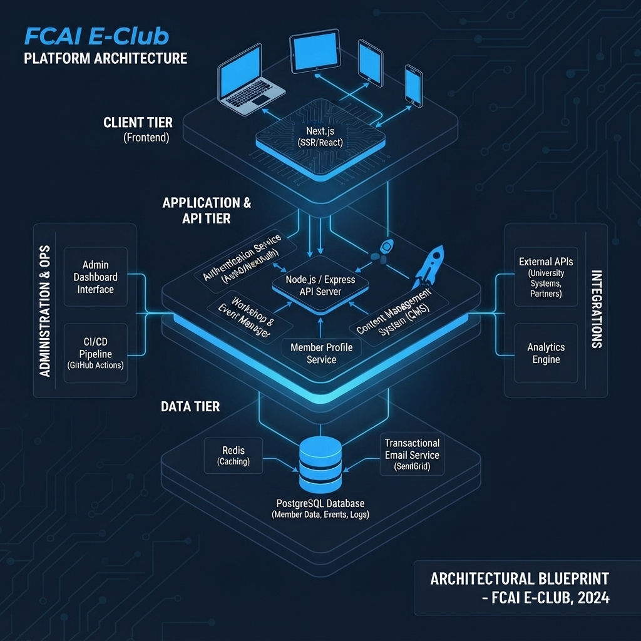
Figure 1: FCAI E-Club Platform Architecture

GLOBAL ELEMENTS
- Navigation Bar (Header):
  - Logo (Left-aligned, "FCAI E-Club Logo Image")
  - Navigation Links: About, Partnerships, Team, Events (consolidating Events, Workshops, and Bootcamps into a single intuitive word).
  - CTA Button: "Join the team" (Directs to application page which will be available on special occasions)
- Footer:
  - Column 1 (Brand): Logo + Slogan ("Engineering the Future").
  - Column 2 (Quick Links): Privacy Policy, Terms of Service, Contact Us, FAQ.
  - Column 3 (Social Links): LinkedIn, GitHub, Instagram, Discord channels.
  - Bottom Bar: Copyright Notice © 2026 FCAI E-Club. All rights reserved.

PUBLIC-FACING PAGES (NON-AUTHENTICATED USERS)
- Landing Page (Hub):
  - Hero Section: Features the tagline "Where tech meets innovation" styled using the Ethnocentric typeface, accompanied by primary CTAs ("Join the team", "Explore Events").
  - Impact Statistics (Expanded to 4 Cards):
    - 500+ Active Members
    - 50+ Events Hosted
    - 20+ Industry Partners
    - 15+ Shipped Projects
  - About Us Snippet: Brief intro linking to the full 'About' page.
  - Upcoming Signals (Events): A scrollable list of upcoming bootcamps and workshops.
  - Testimonials Section: Authentic feedback cards from alumni and active club members detailing their growth and experiences within the community.
  - Backed by Industry Leaders: Partner company logos.
- About Page (Organizational Deep Dive):
- Hero Section: "Engineering the Future" with mission statement.
- Mission Section: Text and a high-res visualization (Image 1).
- Vision Section: Text and an abstract tech network visualization (Image 2).
- Operation Log (Club Timeline): An interactive vertical timeline detailing club history. Each point contains a title, date, and description.
- Partnerships Page:
  - Hero: "Our Ecosystem Partners".
  - Partner Logos Grid: Display of existing partner logos (placeholder boxes in design).
  - "Join Our Network" Section: Pitch text outlining benefits (Access to student talent, Brand visibility, Collaborative projects).
  - Contact Form: Input fields for Company Name, Contact Email, Partnership Interest (Dropdown: Sponsorship, Mentorship, Recruitment), and a "Submit Proposal" button.
- Team Page (Meet the Visionaries):
- Hero: "Meet the Visionaries". Intro paragraph.
- Committees Section: Cards for Technical, Marketing, and Logistics committees, showing member count and a "View Team" CTA.
- All Members Section: A filterable/tabbed grid (All, Technical, Marketing) of all members. Each member card must display: Profile Photo, Name, Title/Role (e.g., Tech Lead), and Primary Committee affiliation.
- Workshops & Events Listing (Main Catalog):
- Hero: "Workshops & Bootcamps".
- Filters: Tabs for All Tracks, Technical, Soft Skills, Business.
- Event Cards: Cards for individual events (e.g., Advanced React Patterns). Each card must display: Status (Open, Closed), Date (MMM DD, YYYY), Title, Description, Track Tag, and a "Read More" CTA.
- Individual Event Detail (e.g., Advanced Prompt Engineering):
- Hero: Event Title, brief description, and "Upcoming Workshop" tag.
- About the Workshop: Detailed text description.
- Instructor Profile: Instructor Photo, Name, Title.
- Curriculum Timeline: Vertical list showing specific times and topics (e.g., 10:00 AM - Foundations).
- Workshop Details Sidebar: Card displaying Date, Time, Location (with "Virtual Link Provided on Registration" note), and Capacity remaining (e.g., 50 Seats, 24 Remaining).
- Enhanced Registration & Application Form: To register for any workshop, bootcamp, or event, users must complete a structured pipeline:
  - Basic Information: Full Name, University Email, Academic Year, and Department/Major.
  - Screening Questions: Custom short-answer fields (e.g., "What is your current experience level with this tech stack?", "What do you hope to gain from this session?").
  - CV / Resume Upload: Secure file upload field accepting PDF or DOCX formats for talent pooling and technical assessment.
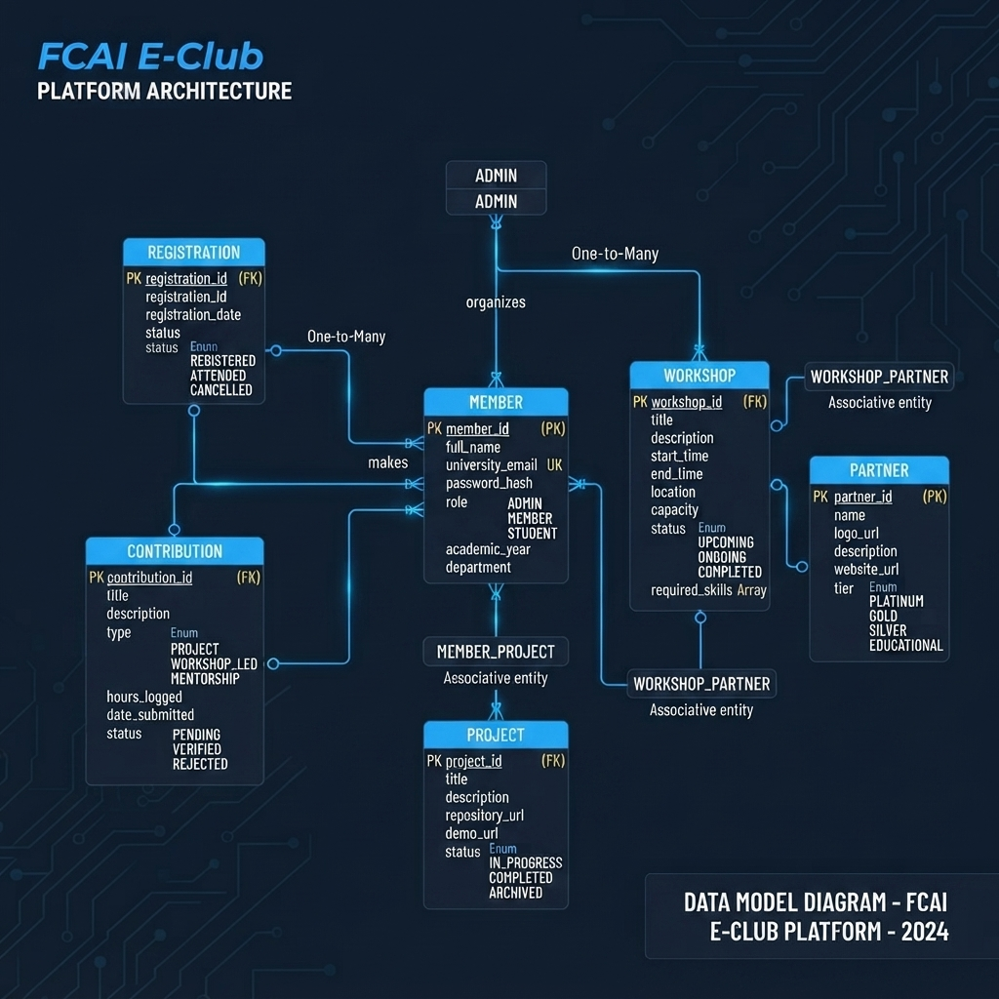
Figure 2: E-Club Platform Architecture (Data Model Diagram)

PART 3: DEVELOPMENT AND DEPLOYMENT ROADMAP
Phase 1: Discovery, Architecture & Design System Setup (Weeks 1–2)
- Database Schema Finalization: Lock in the PostgreSQL schema supporting enhanced entities, including member profiles, event registrations, custom questionnaire responses, and secure file path metadata for CV uploads.
- Design Token Configuration: Establish Tailwind CSS configuration files, setting up custom color palettes, typography scales, and specifically importing the Ethnocentric font family for prominent hero titles.
- Environment & Repository Setup: Initialize the Next.js repository, configure Git branching strategies, set up ESLint/Prettier rules, and establish initial CI/CD staging pipelines via GitHub Actions.
Phase 2: Core Frontend & Public Portal Development (Weeks 3–6)
- Global Components Construction:
  - Navigation Bar: Implement responsive header layout featuring the brand logo, primary navigation links (About, Partnerships, Team, and Events), and the prominent "Join the team" call-to-action button.
  - Footer: Build out the 3-column structural layout containing Column 1 (Logo + "Engineering the Future" slogan), Column 2 (Quick Links), Column 3 (Social Links channels), alongside the bottom copyright notice.
- Landing Page Implementation:
  - Code the Hero section featuring the "Where tech meets innovation" tagline styled in Ethnocentric typography.
  - Develop the 4-Card Impact Statistics grid (Active Members, Events Hosted, Industry Partners, Shipped Projects).
  - Integrate the Testimonials section with dynamic layout components for community feedback and alumni success stories.
- Static & Informational Pages: Build out the About page (incorporating the mission, vision, timeline, and KPI matrix), Partnerships page (with proposal submission form), and the Team directory page.
Phase 3: Events Catalog & Advanced Registration Engine (Weeks 7–10)
- Events & Workshops Portal: Develop the unified Events catalog page supporting filtering across bootcamps, technical workshops, and soft skills sessions.
- Event Detail Page & Testimonials: Build individual event detail views complete with curriculum timelines, instructor breakdowns, and event-specific testimonials.
- Multi-Step Registration & CV Upload Pipeline:
  - Basic Info Collection: Forms capturing full names, university email, academic year, and department.
  - Screening Questionnaire: Dynamic short-answer fields tailored per event to gauge participant experience and motivations.
  - Secure File Upload: Integration with cloud storage supporting PDF and DOCX formats for seamless CV/resume collection and candidate screening.
Phase 4: Authentication & Member Dashboards (Weeks 11–12)
- Authentication Flow: Implement secure authentication via NextAuth supporting credential logins and university email verification.
- Personalized Member Dashboards ("Upcoming Missions"): Build user-specific profile views allowing members to track registered events, manage uploaded resumes, and log project contributions.
Phase 5: Admin Panel & Content Management (Weeks 13–14)
- Admin Dashboard Interface: Develop a secure administrative control center for board members.
- Management Capabilities:
  - Create, Read, Update, and Delete (CRUD) operations for events, bootcamps, and workshops.
  - Review candidate registration responses and download/preview uploaded CVs for talent pooling and team selection.
  - Manage site metrics and update KPI percentages on the About page.
Phase 6: Quality Assurance, Security Audits & Deployment (Week 15)
- Rigorous Testing: Conduct cross-browser checks, mobile responsiveness audits, and end-to-end testing of the registration and CV-upload pipeline.
- Security Hardening: Validate file-upload constraints (file size limits, accepted MIME types) and secure API endpoints against unauthorized data access.
- Production Deployment: Deploy the Next.js frontend to Vercel, host the Node.js/Express backend, and provision production databases and storage buckets.
Phase 7: Stakeholder Handover & Documentation (Week 16)
- Admin Training: Conduct a live walkthrough session for club board members on managing events, screening applications, and reviewing member submissions through the CMS.
- Documentation Handover: Deliver comprehensive API documentation, repository guides, and maintenance playbooks to ensure long-term sustainability.

CLOSING REMARKS
The FCAI E-Club platform represents a pivotal milestone in modernizing how student-led tech organizations operate, scale, and engage with their communities. By bridging robust full-stack architecture with a streamlined user experience, this documentation and blueprint establish a solid foundation for sustainable growth, efficient event management, and impactful industry collaboration.
- Scalable Technical Foundation: Built upon a high-performance Next.js and Node.js stack backed by a relational PostgreSQL database, ensuring long-term maintainability and speed.
- Centralized Operational Hub: Unifies member profiles, contribution logs, workshop tracking, and administrative controls into a single, cohesive digital ecosystem.
- Enhanced Ecosystem Growth: Strengthens visibility for corporate partners while empowering students with a professional platform to showcase their technical projects and milestones.
As the project transitions from architectural planning and database modeling into active development sprints, this platform will serve as the digital backbone for the FCAI Entrepreneurship Club empowering the next generation of student engineers and founders to build, innovate, and lead with confidence.

